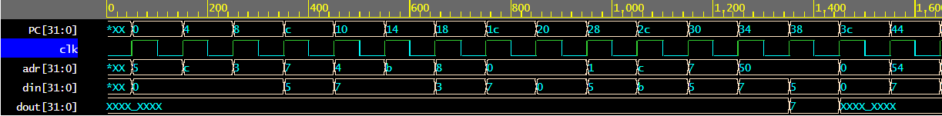Program 4:

Program 1:



Program 2:





Program 3:

